PLANT A STORY GARDEN

THIS IS AN ESPECIALLY GOOD PROJECT FOR EASTER –

MY children really enjoyed planting story gardens at Easter and at Christmas. They are very easy and fun for any time of the year.
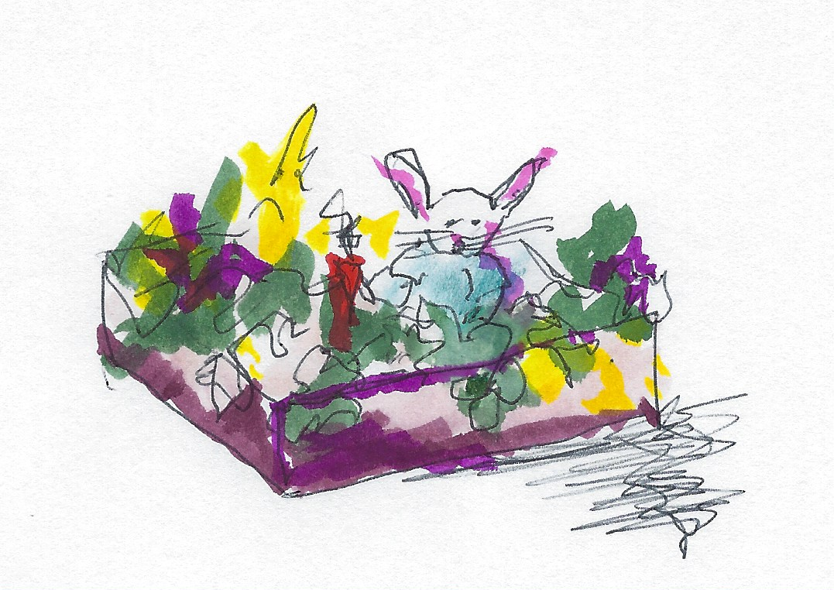

Start with potting soil, an 8X13 or larger sheet
cake pan, and fast growing seeds.
If you provide the correct environmental
conditions, marigold, cosmos, zinnia and
dianthus seed will all sprout within one
week.

Now if you have little kids, a cake pan,
and planting soil, the chances of your providing the correct conditions are not great. Not great at all.
Never mind. Show faith. Plant the seeds. Water them. Believe.

I imagine you don’t have seeds on hand, either, but you can order them online (Burpees.com) or at Bartells, the seed rack is right by the door, so you can buy them without getting close to anyone.

Then the children – and you too – should draw and create figures of the characters in the story, and put them in the dish garden. As the garden begins to grow they can move the figures around. This works especially well with continuing sagas like The Easter Story, or Little House on the Prairie – or Peter Rabbit.

An easy way to make the figures is to draw them on cardboard and fasten them to popsicle sticks. But nothing is easy these days. You’ll think of something.

It’s fun to see the little first sprouts come up – and something is sure to grow. Usually.

Send pictures.

